# Annie Ng

# Feb. 21, 2020

# Foundations of Programming: Python

# Assignment05

Creating Scripts Using Dictionary in PyCharm

# **Introduction**

In this assignment, I will show the steps on creating a script using a dictionary with saved data from a text file, in addition to adding new data and removing data from the dictionary and saving new data to the original text file. This assignment introduces dictionary as another data collection compared to lists from Assignment 04. We will learn how to access elements in a dictionary when creating a script using the data, processing, and presentation process in PyCharm.

## **Dictionary**

Dictionary is very similar to list and are a type of data we work with when managing a collection of data. In list, tuple, or strings the index is a numeric subscript and dictionaries use a key (character) subscript (Root, Randal. _Mod5PythonProgrammingNotes.pdf. p.5). Hence, the syntax of dictionary is different from lists and uses brace {} operator. For this assignment we will use dictionary in our script to display the saved data from a text file.

## **Pseudo-Code**

The pseudo-code we will use, suggested by Professor Root, will unfold below with seven steps from the Assignment05_Starter.py (Root, Randal.Assignment05.pdf. p.2).

## **#When the program starts, load any data in file**

For the program to start and load any data from a text file we must create the text file with data in it. I created a text file and called it ToDoList.txt with two tasks and priorities as the data (Figure1). In Figure 2 the script has a nice header with updates on the change log made by the programmer. The variables used in the script are declared in the beginning in order to neatly structured the data layer. Notice for the text file has to be in read mode when the file is open for data to be loaded in the program/script. The split () function in Line 30 of the script in Figure 2 is to separate the elements of the list based on the commas found in the text file (Root, Randal. _Mod5PythonProgrammingNotes.pdf. p.3). The strip () function in Line 31 to remove the carriage return after Row1. lstTable is puts together the two rows of data from the text onto the same row with the append command. Here we also notice that the dictionary is used as a key described the reference from the text file. When we set the key to task and priority it goes to the respective places for reference. For task it will go straight to Row0 and priority will go straight to Row1.

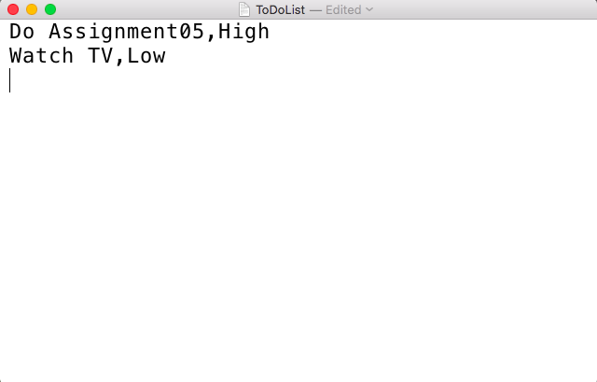

***Figure 1. Creating Text File with Data***

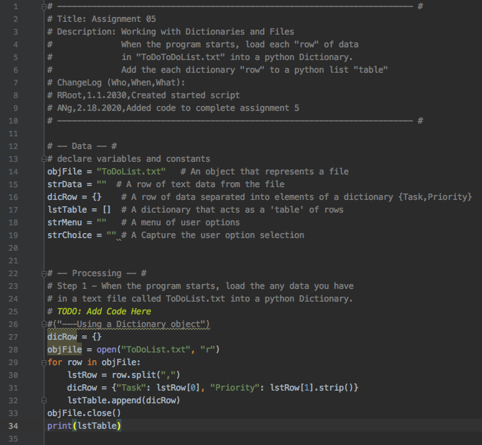

***Figure 2. Screen shot of Script with Changelog, Variables, and Loading Data from Text File***

## **#Display a menu of choices to the user**

First, we can create a menu of choices for our user to select using the list table function followed by the options: add data to list, display current data, exit and save data to file. Here, we put the menu of choices in a while loop. The while loop repeats part of the code based on a condition (Python Programming for Absolute Beginner, 3rd Edition, Michael Dawson, Cengage Learning 2010, p. 88). The condition is that the menu of options will continue to loop until the user chooses an option, which will break the loop and move on to the option that the user chooses (Figure 3).

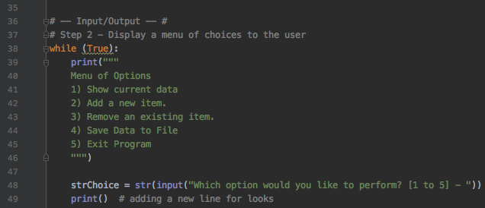

***Figure 3. Display Menu of Options for User in While Loop***

## **While and For Loops**

The while loop is used in programming to repeat a command when the statement is true (Root, Randal. _Mod3PythonProgrammingNotes.pdf. p.12). In the assignment we want the menu of choices to appear repeatedly until the user chooses either option 1, 2, 3, 4, or 5. Once the user chooses one of the options the loop will break and move on to the one of the options. The for loop is used to loop through all items in the collection of data. One difference of the for loop and the while loop is that the for loop will automatically stop once it reaches the last value of the collection. We used the for loop in the script to go through all the task and priority in the text file.

## **#Show the current items in the table**

If the user selects option 3 it prints the elements from the list/table.

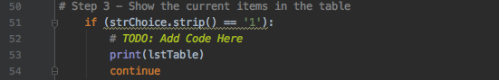

***Figure 4. Screen shot of Code to display the Current Items in the Table***

## **#Add a new item to the list/table**

The user is being asked to enter data about task and priority to the list/table.

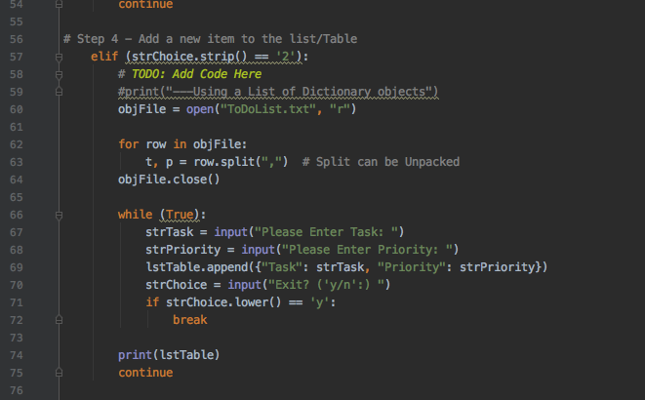

***Figure 5. Screen Shot of Code to Add a New Item to the List/Table***

## **#Remove a new item from the list/table**

After adding data to the table the user can also remove specific elements from the list/table.

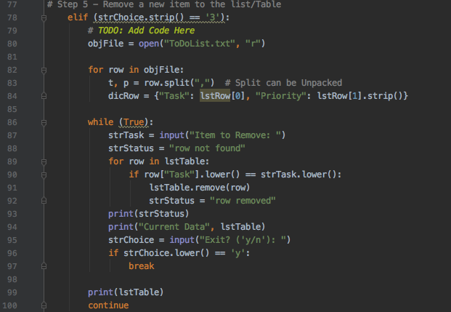

***Figure 6 Removing Items From the List/Table and Showing Current Data***

## **#Save tasks to the ToDoList.txt file and Exit Program**

After receiving the input from the user the data is usually gone if the program stops running or if we do not save it. We will save the data in a text file.

First, we will use the open function when we create a new file or use an existing file, so the data can be retrieved when we open it (Intro to Python Mod03, Root, 2019). Please note the name of the file ends in a “.txt” as the information saved in a text file. For the open function, we have to name the file we will use and the activity that is performed on the file. In this script, you will see “w”, which means the data will be written over (Figure 7).

Next, we have the write function for writing data into the file. As it shows in the script the data that will be written is the task and priority. At the end there is a “\n” to indicate the value of the item will be on the next line when data is entered in the program (Figure 7).

Last, it is recommended to close the file so it shows the end of the program. On Step 7 the script will print a friendly message to the user to inform it is the end of the program.

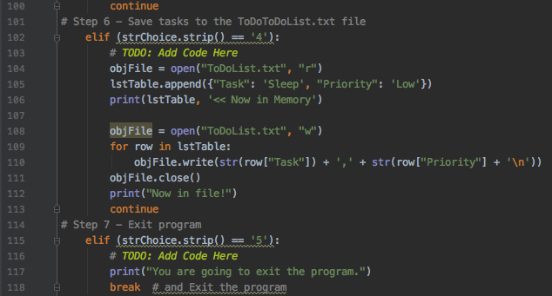

***Figure 7. Save Data to a Text File and Exit Program***

### **Summary**

In this assignment we are creating a script using a dictionary with saved data from a text file, in addition to adding new data and removing data from the dictionary and saving new data to the original text file. In the assignment we are seeing how dictionaries are used like spreadsheets and the keys are like the columns making the list easier to understand.

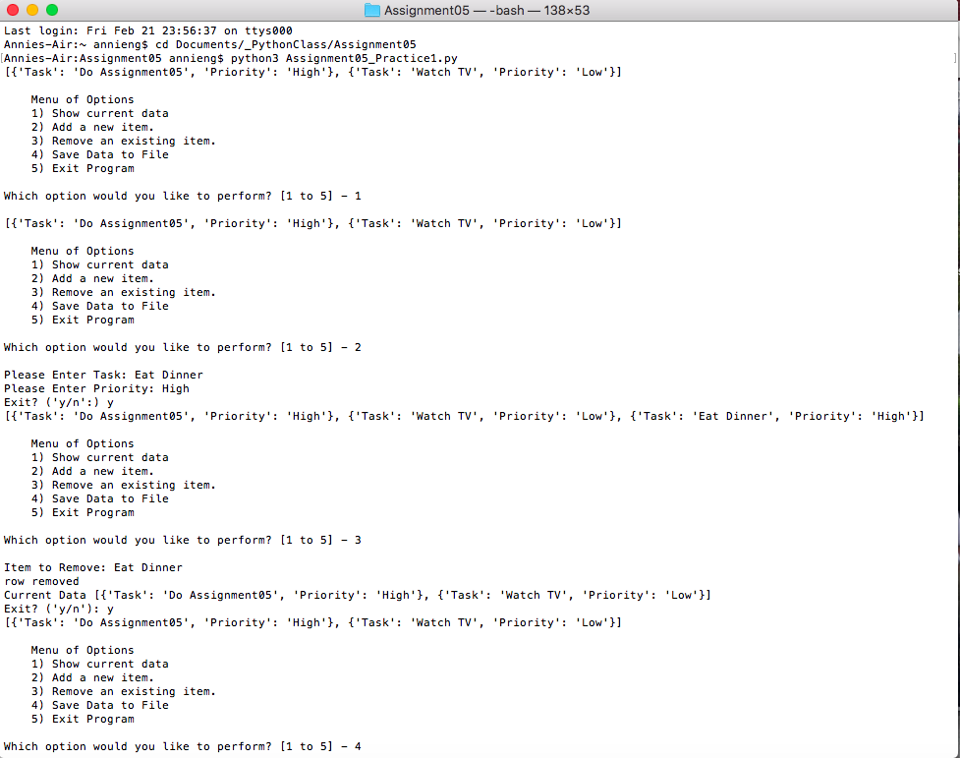

***Screen shot of Script in Terminal Mac OS***

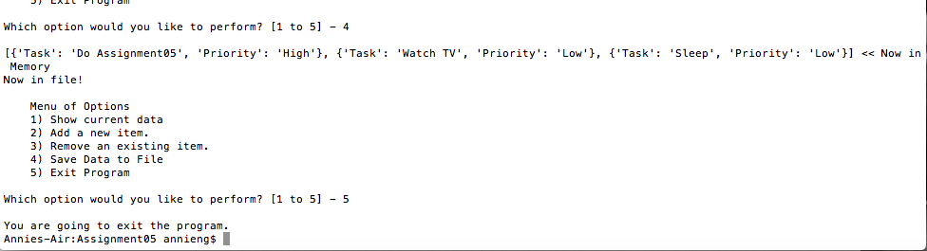

***Screen shot of Script in Terminal Mac OS (Continuation)***

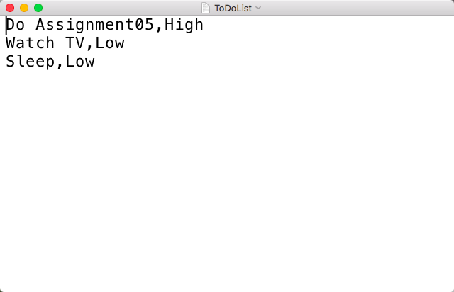

***Screen shot of Data Saved in Text File***

***Screen Shots of Script Running in PyCharm***

